Liam Cui

HW2 CSCI 661

$M_{1}=(Q,Σ,δ,q_{0},F)$

$Q=\{q0, q1, q2, q3, q3, q4, q5$}

$$Σ=\{h, q\}$$

|  |  |  |
| --- | --- | --- |
| State | q | h |
| $$q0$$ | $$q1$$ | $$q3$$ |
| $$q1$$ | $$q1$$ | $$q2$$ |
| $$q2$$ | $$q5$$ | $$q5$$ |
| $$q3$$ | $$q4$$ | $$q3$$ |
| $$q4$$ | $$q5$$ | $$q5$$ |
| $$q5$$ | $$q5$$ | $$q5$$ |

$$δ=$$

$$q_{0}=q_{0}$$

$$F=\{q_{2}, q_{4}\}$$

$s_{1}=qqqqhhh$

q0 to q1

q1 to q1

q1 to q1

q1 to q1

q1 to q2

q2 to q5

q5 to q5

Outcome is q5 which is not accepted

$s_{2}=hhhhqqq$

q0 to q3

q3 to q3

q3 to q3

q3 to q3

q3 to q4

q4 to q5

q5 to q5

Outcome is q5 which is not accepted

$s_{shortest accept}=qh$

$s_{longest accept}=\overline{q}h$

$s_{shortest reject}= ϕ$

$s_{longest reject}= \overline{q}$

$L\left(M_{1}\right)=\left\{w ϵ Σ^{*}\right| w starts with q followed by any number of q^{'}s$

$$and then ends with h xor w starts with h followed by any number$$

$$of h^{'}s and then ends with q$$

1. The argument for union is that the two FSA can be rewritten as a single FSA using the cartesian product of the states of both originals, where accepted states of the new are the products containing any accepted state from either FSA. For intersection we would still construct the cartesian product FSA however the accepted states are now limited to any cross product state containing at least one accepted state from both original FSAs.
2. We already know that the intersection of regular languages is closed. Then if given the statement that regular languages are closed by complement, we can say that the set difference of regular languages is closed because the set difference of 2 languages is the same as the union of the first language (in the set difference) with the other language’s (second language in set difference) compliment.
3. Because we know that the set difference of regular languages are closed and that the intersection and union of languages are closed, we can apply the truth that symmetric difference is the same as the set difference of the union minus the intersection to languages. Therefore, the symmetric difference of regular languages is also closed.
4. 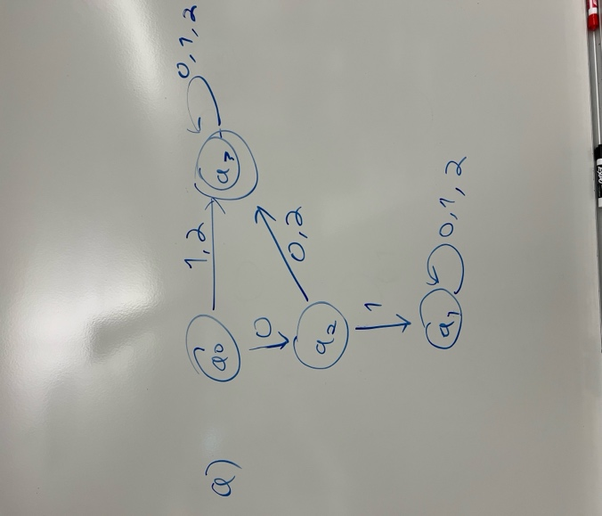 Every string that starts with 01 ends up at q1 which is a reject state
5. 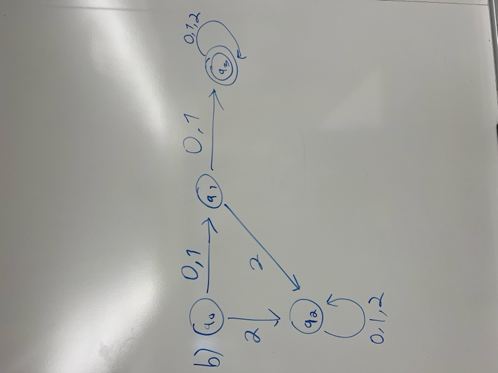 Every string containing a 2 in the first two symbols ends at q2 which is a reject state.
6. 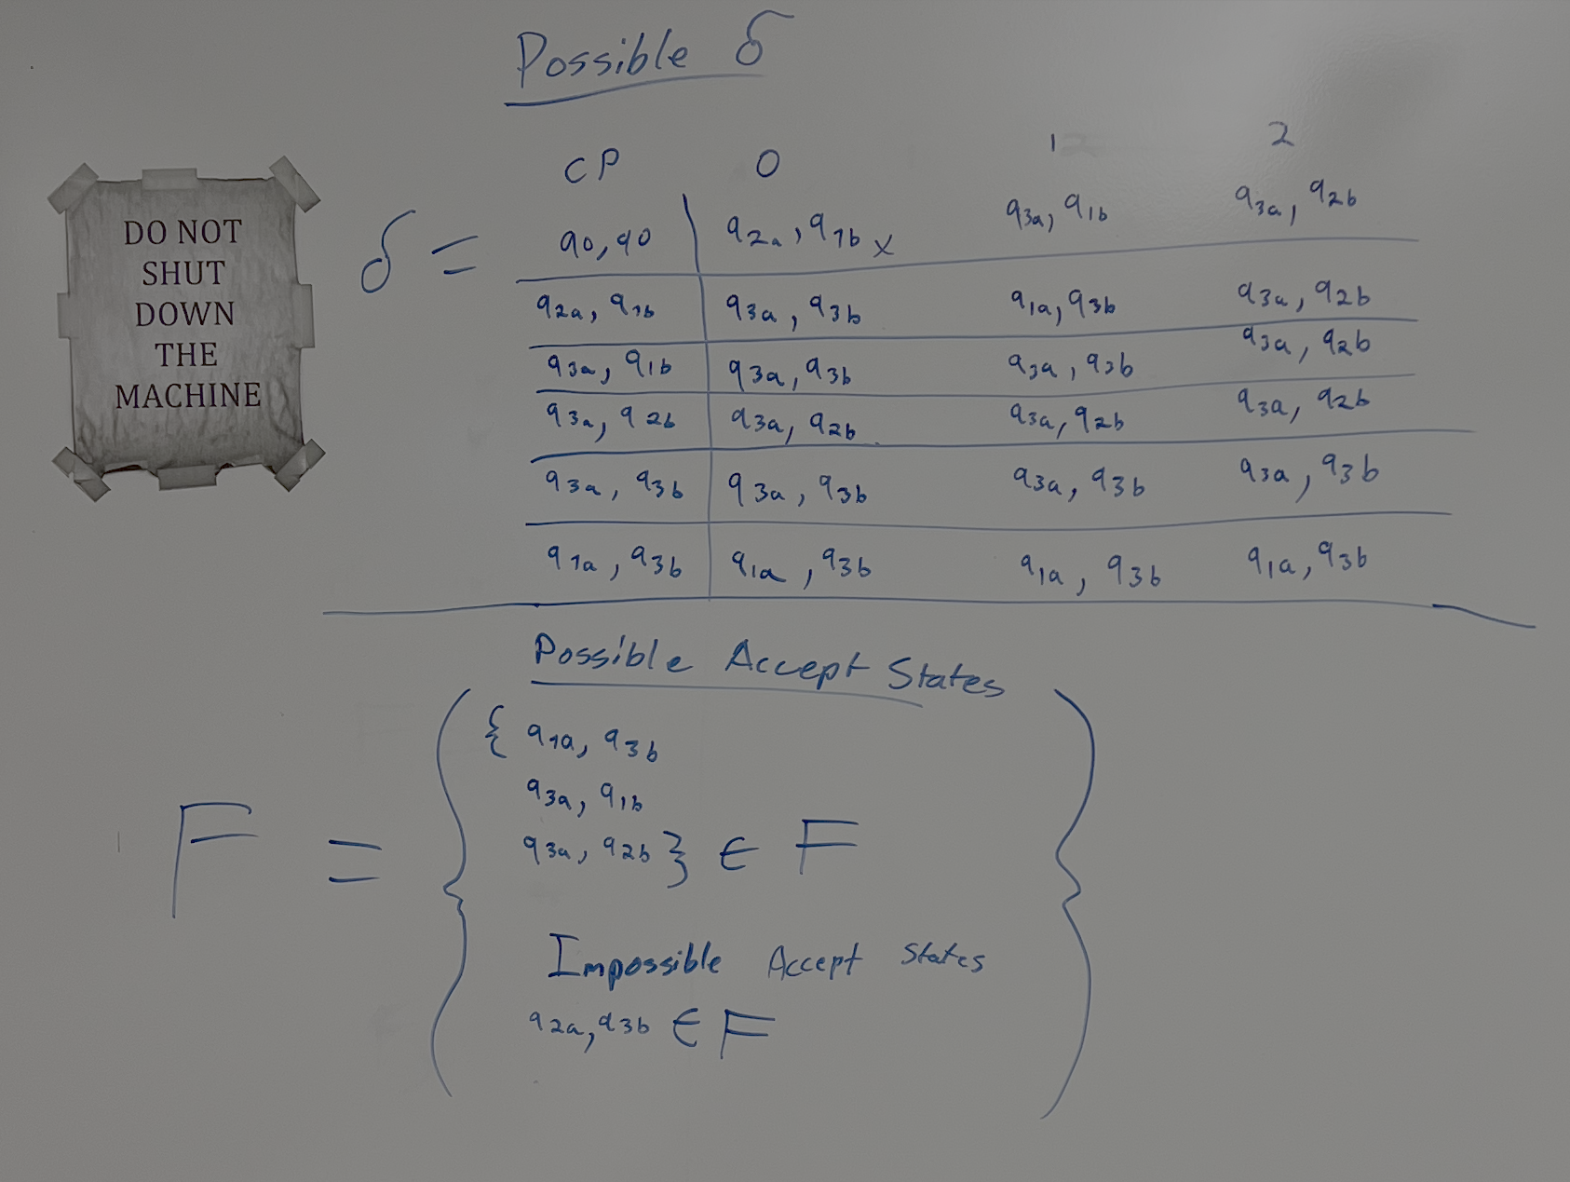

Therefore M3=

$Q=\{q0, q1, q2, q3, q3, q4,q5$}

$$Σ=\{0, 1, 2\}$$

|  |  |  |  |
| --- | --- | --- | --- |
| State | 0 | 1 | 2 |
| $$q0$$ | $$q1$$ | $$q2$$ | $$q3$$ |
| $$q1$$ | $$q4$$ | $$q5$$ | $$q3$$ |
| $$q2$$ | $$q4$$ | $$q4$$ | $$q3$$ |
| $$q3$$ | $$q3$$ | $$q3$$ | $$q3$$ |
| $$q4$$ | $$q4$$ | $$q4$$ | $$q4$$ |
| $$q5$$ | $$q5$$ | $$q5$$ | $$q5$$ |

$$δ=$$

$$q_{0}=q_{0}$$

$$F=\{q_{2},q_{3}, q_{5}\}$$

1. The Language for m1 would not exist because there would be no possible way to reach the accept state of q3 from the q0 start state. This can be proven by the delta values of q0, q2, and q4.

DFA =

$Q=\{q0, q1, q2, q3, q3, q4, q5$}

$$Σ=\{0, 1, 2\}$$

$$δ=$$

|  |  |  |  |
| --- | --- | --- | --- |
| State | 0 | 1 | 2 |
| q0 | q2 | q2 | q4 |
| q2 | q4 | q4 | q0 |
| q4 | q0 | q0 | q2 |
| q1 | q3 | q3 | q5 |
| q3 | q5 | q5 | q1 |
| q5 | q1 | q1 | q3 |

$$q_{0}=q_{0}$$

$$F=\{q_{3}\}$$

As you can see, regardless of any string, there is no possible path from q0 to q3. The only possible states you can end on if the start is q0 are q0, q2, or q3.

1. The accepting binary string must be of length of at least 3 and the length be a multiple of 3. This allows the string to be separated in triplets of S, T, and U. U must equal to the xor of S and T.

We then know the accepting triplet of strings are 000, 110, 011, and 101 and the rest of the triplets are reject states.

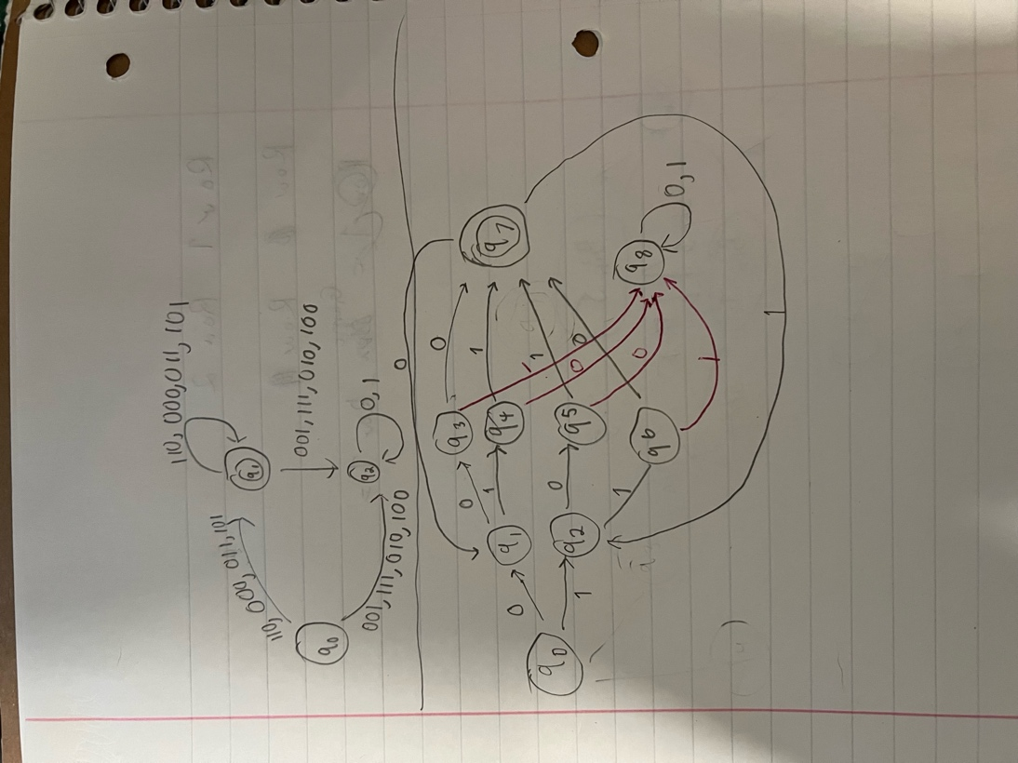

$Q=\{q0, q1, q2, q3, q3, q4, q5,q6,q7,q8$}

$$Σ=\{0, 1\}$$

|  |  |  |
| --- | --- | --- |
| State | 0 | 1 |
| $$q0$$ | $$q1$$ | $$q2$$ |
| $$q1$$ | $$q3$$ | $$q4$$ |
| $$q2$$ | $$q5$$ | $$q6$$ |
| $$q3$$ | $$q7$$ | $$q8$$ |
| $$q4$$ | $$q8$$ | $$q7$$ |
| $$q5$$ | $$q8$$ | $$q7$$ |
| $$q6$$ | $$q7$$ | $$q8$$ |
| $$q7$$ | $$q1$$ | $$q2$$ |
| $$q8$$ | $$q8$$ | $$q8$$ |

$$δ=$$

$$q_{0}=q_{0}$$

$$F=\{q_{7}\}$$

1. Bin(w) xor Bin(v) = Bin(Sw xor Sv) * Bin(Tw xor Tv) * Bin(Uw xor Uv)

This diagram below is the xor of any accepted binary triplet with another triplet

|  |  |  |  |  |
| --- | --- | --- | --- | --- |
| Accepted binary triplet (SiTiUi) | 000 | 110 | 011 | 101 |
| 000 | 000 | 110 | 011 | 101 |
| 110 | 110 | 000 | 101 | 011 |
| 011 | 011 | 101 | 000 | 110 |
| 101 | 101 | 011 | 110 | 000 |

Because all the XOR of the valid STU binary triplets result in other valid STU triplets we can conclude that L4 is closed under XOR.